**Assignment #01**

### Name Basharat Hussain

### Roll no: P17-6102

### Section: A

Write any 30 CMD commands for windows with short description and screenshot of the each output in pdf form.

### See Directory

### List the contents of one or more directory.

### 

### Change Directory

CD (Change Directory) is a command used to switch [directories](https://www.computerhope.com/jargon/d/director.htm) in MS-DOS and the Windows command line.

### 

### Create New File

### You can make a new directory using the [MKDIR (Make Directory)](http://en.wikipedia.org/wiki/Mkdir) or the *MD* command. The syntax of these commands is “MKDIR Folder” or “MD Folder”

### 

### View your Windows license key

### Lost your Windows license key again have you? If it’s not written on a sticker on your computer’s case then you can find it by typing “wmic path softwarelicensingservice get OA3xOriginalProductKey” into the command prompt window and hitting Enter.

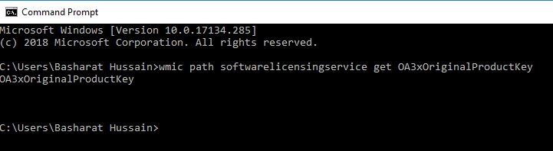

1. **Copy Directory**

Copy Directory

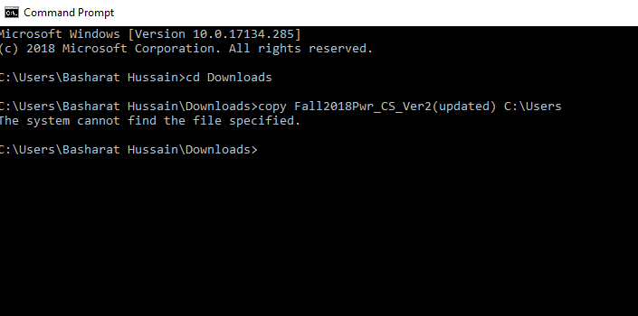

1. **Cls Command**

Clear the Screen

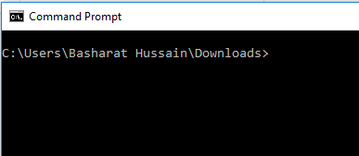

1. **Cd.. Command**

Back to previous directory

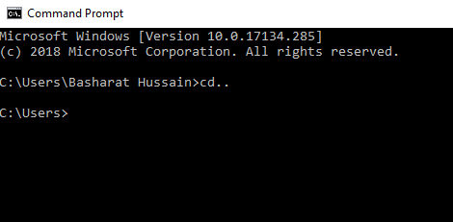

1. **Date Command**

The date command can be used to look at the current date of the computer as well as change the date to an alternate date.

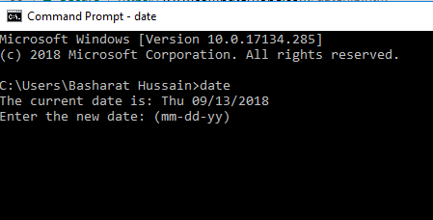

1. **Time Command**

Allows the user to view and edit the computer's time.

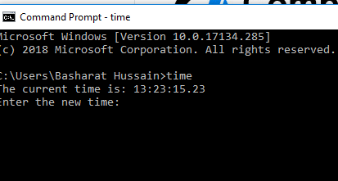

### ****Find information about your computer****

### It’s not always easy to work out where to find your computer’s specs—that is, it’s not easy unless you use the command line. Type “systeminfo”, press Enter, and you get a detailed readout of everything from the amount of RAM installed to when the last reboot was.

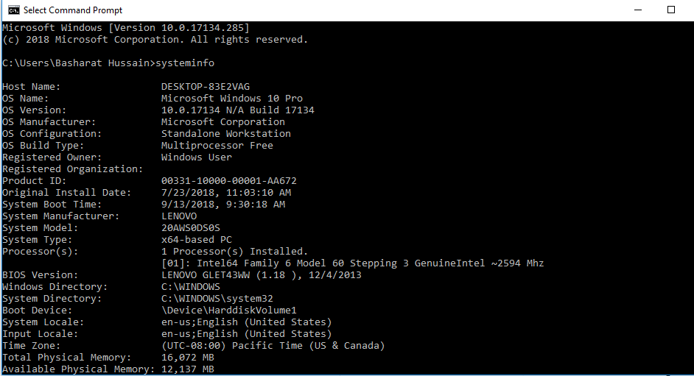

1. **Color Command**

**e.g. color 0A**

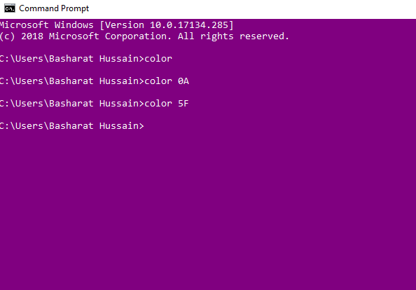

### ****View installed drivers****

If you’re troubleshooting hardware problems or just want to know if something’s installed successfully, seeing a list of installed drivers can help: type “driverquery”, hit Enter, and you get a list of all the current Windows drivers, alongside install dates and display names.

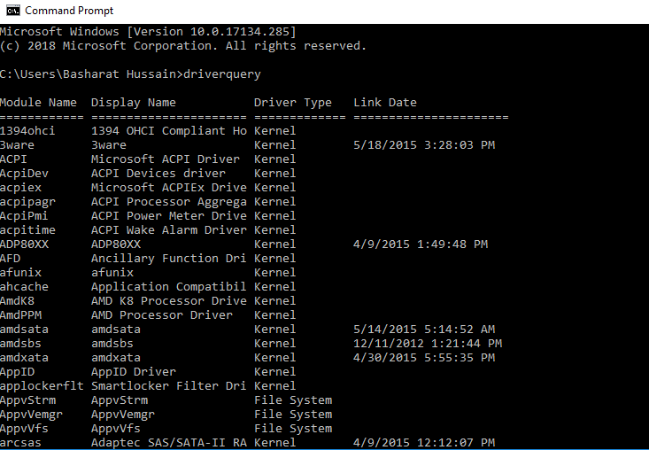

### ****Get a dictionary definition****

If you don’t happen to have a proper paper dictionary or a search engine on hand then Terminal can look up words for you as well. All you need to do is type “curl dict://dict.org/d:word”, replacing that final “word” with the one you want defining.

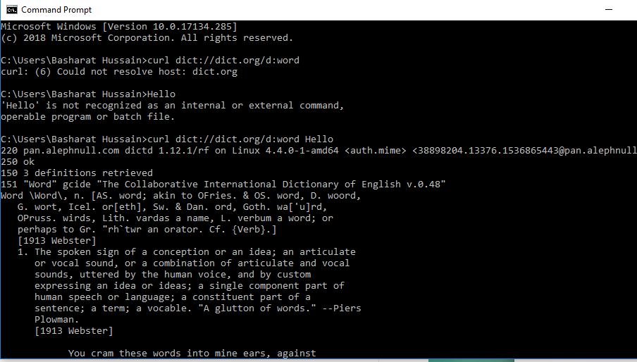

## **Get help on almost every Command**

This is especially helpful for beginners, but advanced users may get to learn few things too. You can easily get info on almost every command you provide in the Command Prompt. Information includes complete details of what a command does and what process are used, it may also show some examples.

To get the help, just type “/?” at the end of the command of which you need info. For example, you can type “**ipconfig/?**”, and you will get all the info.

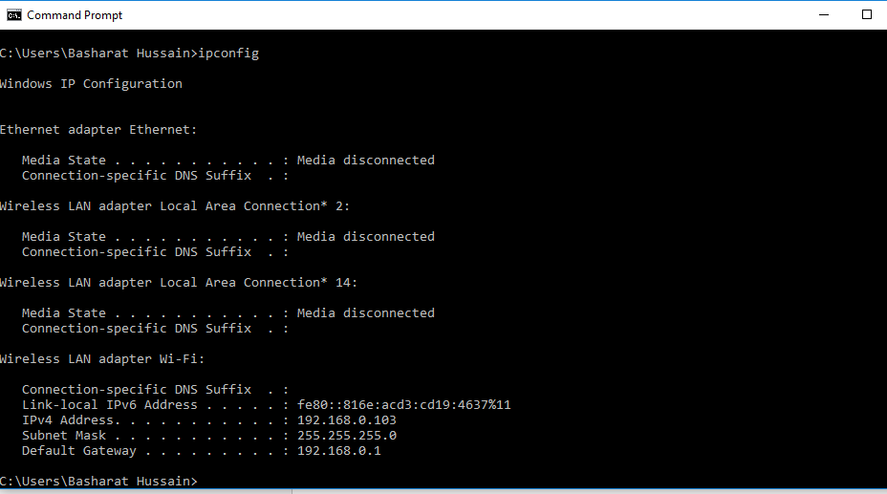

## **Check IP address of any Website**

You can see IP address of any website just by entering “nslookup” command along with the name of the website. For example, you can type “**nslookup beebom.com**” to find its IP address.

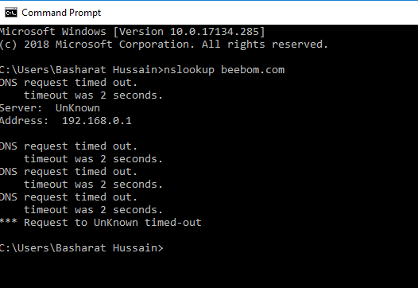

1. **Sort**

Sort will accept a redirected or piped file input and TYPE the file, sorted line by line.

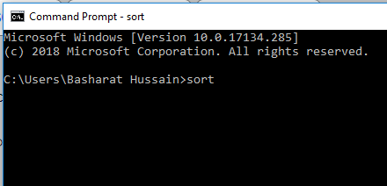

# 

## **Execute Multiple Commands**

You can easily execute one command after another by provide all the commands and putting “&&” between each command (may save some time). For example, you can type “**ipconfig && dir**” to execute both commands one after another.

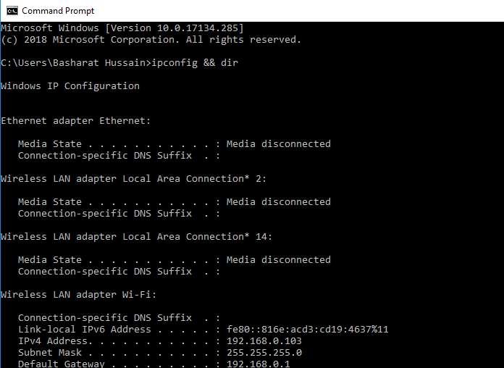

## **Check Default Programs**

You can check which applications are used to open specific types of programs. For this purpose, just type “**assoc**” in the Command Prompt and hit enter. You will see all the extensions and their associated program that opens them written next to them.

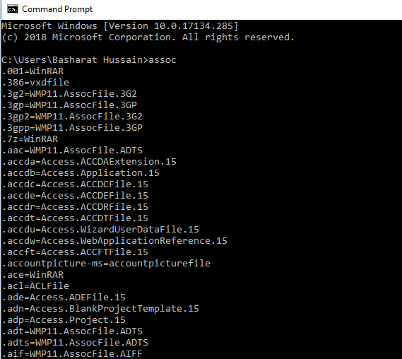

1. **SHUTDOWN.exe**

Shutdown the computer



## **Check Default Programs**

You can check which applications are used to open specific types of programs. For this purpose, just type “**assoc**” in the Command Prompt and hit enter. You will see all the extensions and their associated program that opens them written next to tem.



## **26) Get PC Drivers List**

You can open list of all the drivers installed on your PC with just a single command. Just type “**driverquery**” in the Command Prompt and press Enter. After a short delay, you will see all the drivers installed in your PC along with, Name, Type and Link date.

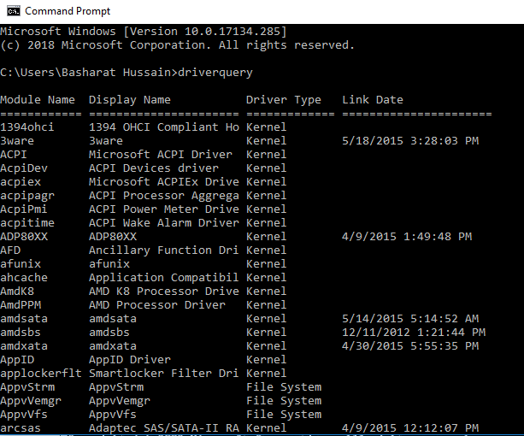

1. **CALL**

Call one batch program from another, or call a subroutine.

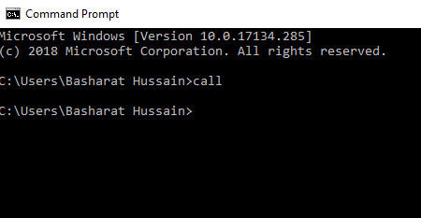

1. **Move one Disk To another**

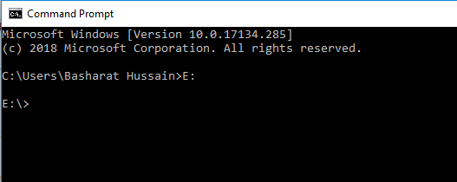

## **Check Default Programs**

You can check which applications are used to open specific types of programs. For this purpose, just type “**assoc**” in the Command Prompt and hit enter. You will see all the extensions and their associated program that opens them written next to them.

